**The Archdeacon of Lancaster**

*The Venerable David Picken*

**THE ARCHDEACONRY OF LANCASTER**

**DEANERY OF POULTON**

**(NB This notice should be displayed prominently on the church notice board on the next Sunday after receiving it)**

To the **Churchwardens**

I hereby give notice that you are requested to attend the Visitation for the Admission of Churchwardens to be held at **Bispham All Hallows on 22 June 2023 at 7.30 pm.**

It is essential that those who have been elected to serve as Churchwardens for the year 2023-2024 should be present on this occasion to be sworn in by the Archdeacon of Lancaster and having first been elected by due process.

A form of nomination for Churchwardens, with details of how nominations should be made, together with details of those who are excluded from election, are provided on the Diocesan website, [www.blackburn.anglican.org/Archdeacons](http://www.blackburn.anglican.org/Archdeacons) pages. Please print this notice as appropriate.

If you are unable to attend this visitation, please advise [gillian.beeley@blackburn.anglican.org](mailto:gillian.beeley@blackburn.anglican.org).

31 March 2023

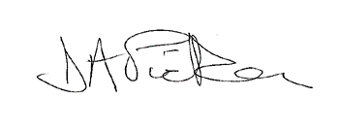

Ven David Picken

Archdeacon of Lancaster